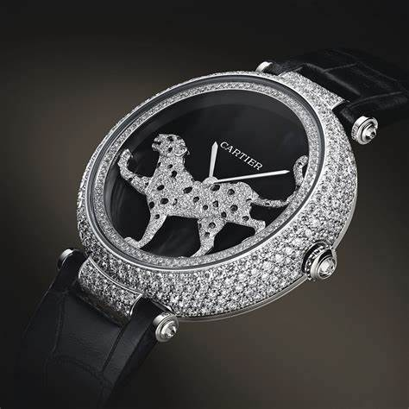Cartier

Description: Cartier offers an exquisite range of women’s watches that combine elegance, innovation, and timeless design. Known for their bold yet graceful aesthetics, Cartier watches are more than just timepieces — they are iconic symbols of luxury and sophistication. The **Balloon Bleu de Cartier** is a standout model, recognized for its distinctive round case, blue sapphire cabochon crown, and Roman numeral dial, available in various sizes and materials, including stainless steel, gold, and diamond-set designs. The **Tank collection** is another Cartier classic, inspired by military tanks from World War I, featuring a rectangular case, clean lines, and Art Deco elegance. The **Tank Françoise, Tank Louis Cartier,** and **Tank Americana** variations each offer a unique spin on this timeless silhouette.

For a more playful yet refined option, the **Panther de Cartier** captures the brand's feline inspiration, with a sleek, flexible bracelet and square case, embodying both glamour and modernity